**5. Kubernetes Pods Demo**

--- **Reference** - <https://github.com/stacksimplify/kubernetes-fundamentals>

--- Reference - <https://github.com/stacksimplify/kubernetes-fundamentals/tree/master/02-PODs-with-kubectl>

**# Get Worker Node Status**

--- **kubectl get nodes**

**# Get Worker Node Status with wide option**

--- **kubectl get nodes -o wide** – it will give us the wide information.

**Create a Pod**

**# Template**

--- **kubectl run <desired-pod-name> --image <Container-Image> --generator=run-pod/v1**

**# Replace Pod Name, Container Image**

--- **kubectl run my-first-pod --image stacksimplify/kubenginx:1.0.0 --generator=run-pod/v1**

--- **Important Note**: Without --generator=run-pod/v1 it will create a pod with a deployment which is another core kubernetes concept which we will learn in next few minutes.

--- **Important Note:** With Kubernetes 1.18 version, there is lot clean-up to kubectl run command. The below will suffice to create a Pod as a pod without creating deployment. We don’t need to add --generator=run-pod/v1

--- **kubectl run my-first-pod --image stacksimplify/kubenginx:1.0.0**

**List Pods**

--- Get the list of pods

**# List Pods**

--- **kubectl get pods**

**# Alias name for pods is po**

--- **kubectl get po**

**List Pods with wide option**

--- **note** - List pods with wide option which also provide Node information on which Pod is running

--- **kubectl get pods -o wide**

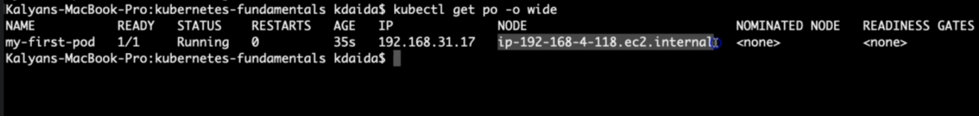

**What happened in the back group when above command is run?**

--- **Kubernetes created a pod**

--- **Pulled the docker image from docker hub**

--- **Created the container in the pod**

--- **Started the container present in the pod**

**Describe Pod**

--- Describe the POD, primarily required during troubleshooting.

--- Events shown will be of a great help during troubleshooting.

**# To get list of pod names**

--- **kubectl get pods**

**# Describe the Pod**

--- **kubectl describe pod <Pod-Name>**

--- **kubectl describe pod my-first-pod**

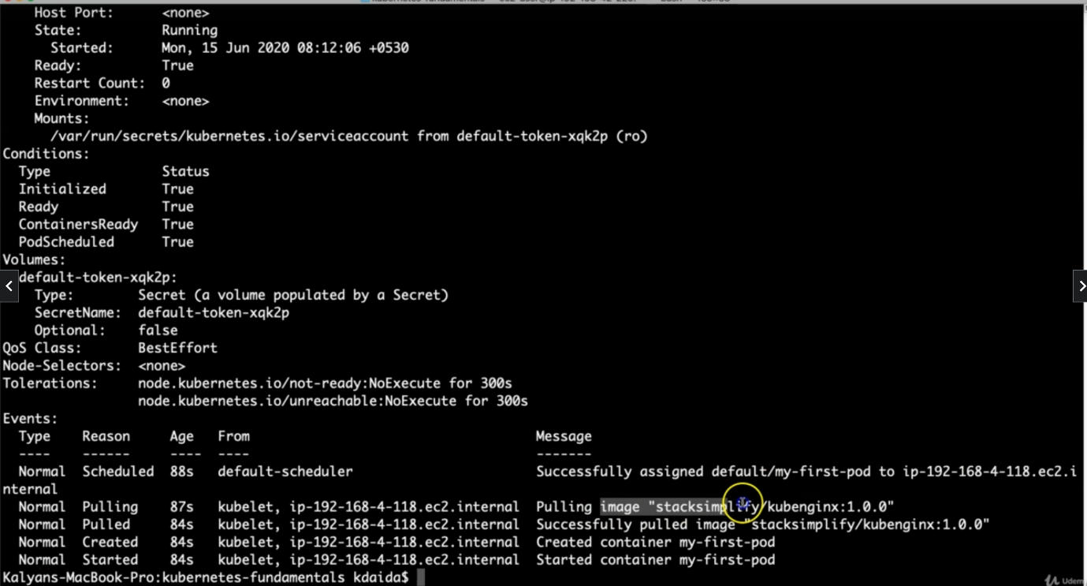

--- **note** – you can see here that the default/my-first-pod is assigned to ip-192-168-4-118.internal.

--- **note** – that below information tells about the kubernetes 1st created pod, 2nd it is pulled the image from the dockerhub, 3rd it created a container inside of pod, 4th it started the container.

--- **note** – kubectl describe will give end to end information about pod. It will provide so much information.

**Access Application**

--- Currently we can access this application only inside worker nodes.

--- To access it externally, we need to create a NodePort Service.

--- Services is very important concept in Kubernetes.

**Delete Pod**

**# To get list of pod names**

--- kubectl get pods

**# Delete Pod**

--- **kubectl delete pod <Pod-Name>**

--- **kubectl delete pod my-first-pod**